**Exercise: Shell scripts**

1. Write a shell script to get the current date, time, username and current working directory. 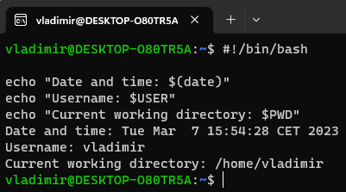
2. Write a shell script that prints “I love learning about DevOps” on the screen. Message should be a variable.

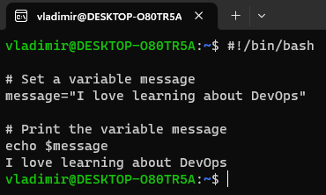

1. Write a shell script that displays “plan code build test release deploy” on the screen with each appearing on a separate line. 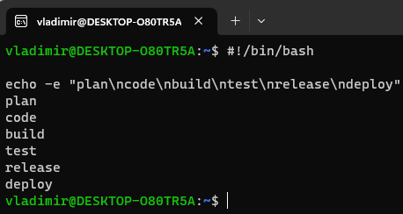
2. Write a shell script that prompts the user for a name of a file or directory and reports if it is a regular file, a directory, or another type of file. Also perform a ls command against the file or directory with the long listing option. 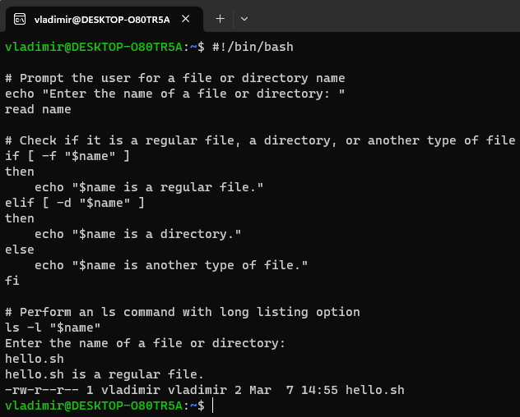
3. Use arguments in a script. Total number of arguments should be three.

*#!/bin/bash*

*# Check that three arguments were provided*

*if [ $# -ne 3 ]*

*then*

*echo "Error: Must provide three arguments."*

*exit 1*

*fi*

*# Print the three arguments*

*echo "The first argument is: $1"*

*echo "The second argument is: $2"*

*echo "The third argument is: $3"*

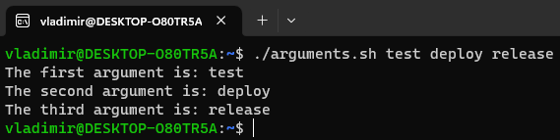

1. Write a script that will output your name out of a variable and will display the server uptime

